# Medical Image Computing 2015-2016

# Question 1

Not examinable (?)

# Question 2

## Part a

A **rigid** transformation is composed of rotation and translation. In 3D, a rigid transformation has 6 degrees of freedom (3 for translation, 3 for rotation).

A **similarity** transformation is composed of a rigid transformation *and* uniform scaling.

## Part b

An image-to-world transformation consists of spacing, rotation and shift.

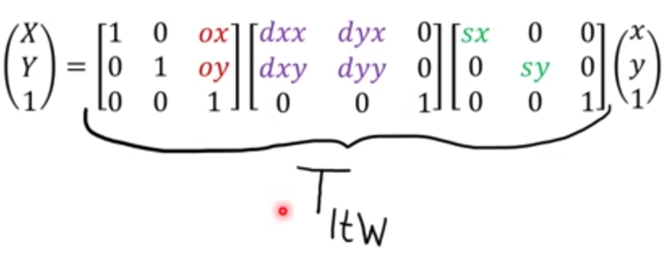

## Part c

## Part d

* Sum of squared differences assumes that the intensities have the identity relationship.
* Correlation coefficient assumes a linear relationship between the intensities of the two images.
* Mutual information assumes a statistical relationship between the intensities of the two images.

## Part e

# Question 3

## Part a

Unsupervised:

* Anomaly detection.
* Discovering novel semantic subsets of data via clustering.

Supervised:

* Lesion segmentation.
* Patient age prediction.

## Part b

In K-Means:

1. Assign each point to a cluster.
2. Calculate mean distance of each cluster.

The eigenvectors (principal components) determine the directions of the new feature space. The corresponding eigenvalues give the variance in each of these directions.

It would not be sensible to apply PCA because PCA can only be used for *linear* data encoding.

[From practice question model answers] It’s not reasonable, as the data is clearly not well represented by orthogonal principal modes as they arise from PCA.

## Part c

We can use either one-vs-one or one-vs-all. Assume a multi-class classification problem with K classes:

* In one-vs-all, we train one classifier for each class for a total of K. All the samples of the corresponding class are treated as positive labels, and the rest negative.
* In one-vs-one we train each classifier to distinguish between two pairs of classes, for a total of K(K-1)/2 classifiers. At prediction time, each classifier votes.

Linear regression is used for regression problems, whereas logistic regression is used for classification problems. Linear regression optimises ordinary least squares, whereas logistic regression optimises maximum likelihood.

Alternate: Linear regression tries to find a curve to fit the data, while logistic regression tries to find a decision boundary to separate the data.

High bias is a result of underfitting – it means the predictions are biased towards the mode, but the model doesn’t explain the training data well. High variance is a result of overfitting – a small x axis change can cause a large change in the output.